**Experiment No.2 Date:21/09/2021**

Verification of Kirchhoff’s Current Law

**Objectives:**

1. To verify KCL and find the Nodal Voltages
2. To verify it on breadboard on [www.tinkercad.com](http://www.tinkercad.com/)

**Verification of KCL and Nodal Voltages**

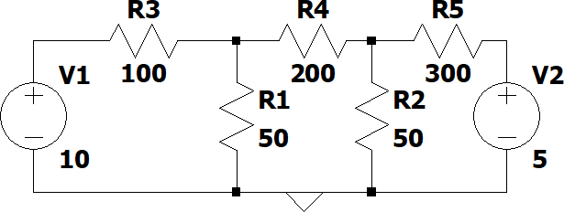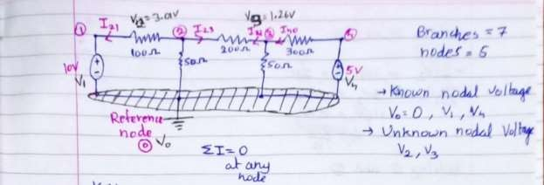

**Observation:**

|  |  |  |
| --- | --- | --- |
| **S.No** | **Parameter to be measured** | **Value Measured with Units** |
| 1 | V2 | 3.01V |
| 2 | V3 | 1.12V |
| 3 | I12: Current through R1 | 0.069A |
| 4 | I23: Current through R2 | 0.009A |
| 5 | I34: Current through R3 | -0.0129A |
| 6 | I20: Current through R4 | 0.0602A |
| 7 | I30: Current through R5 | 0.0225A |

**Calculations:**

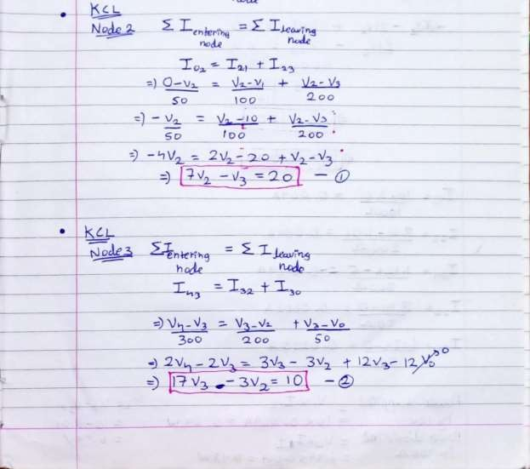

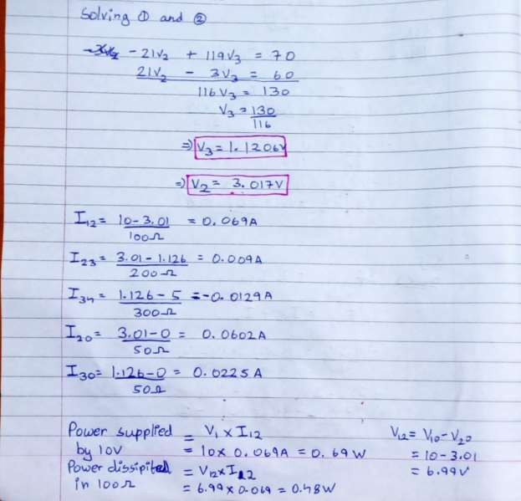

**TinkerCAD Circuit:**

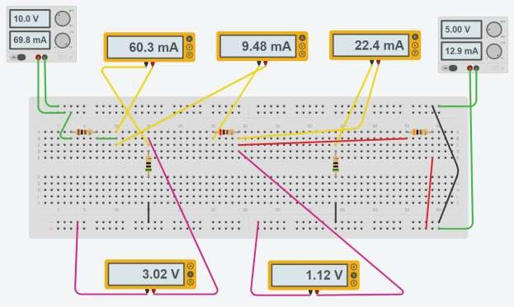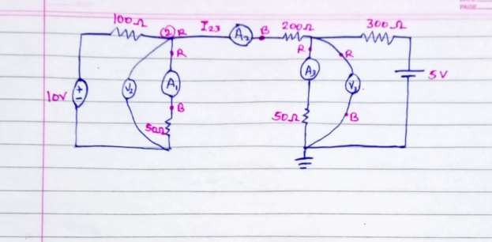

Shareable link: https:/[/www](http://www.tinkercad.com/things/9ctjWHqaSu7-stunning-).[tinkercad.com/things/9ctjWHqaSu7-stunning-](http://www.tinkercad.com/things/9ctjWHqaSu7-stunning-) densor/editel?sharecode=V3w64UNp21IDgh79C7hXV44ZR9-8KyT61ctrX9P6H7o

**To Do:**

1. Verify KCL using the above measurements
2. Paste the Sharable link and Screenshot of Simulation done in TinkerCAD
3. Picture of the theoretical calculation done in your notebook